**!TD**

## Must Haves:

**<Vision Statement>**

With the development of this game, it is striven to provide the players with a multi-action game, in which the main keys to success are good awareness and high action per minute (apm). The goal of the player is to destroy a castle by sending minions into it. By progressing throughout the game the player could upgrade his minion forces as well as unlock new ones.

**<Game Structure>**

The game screen is divided into 3 different parts. The upper half is for the main game, whereas the bottom 2 quarters are for the side games (also referred to as mini-games). The side games could be used by player to gain different benefits for the main game. When a mini-game is chosen, the other one is instantaneously locked. In such way the user cannot change their mind in case the side game is too hard to complete and will be forced to pay the consequences of losing it by gaining a negative de-buff, such as giving back some health points to the castle. On the other hand, the successful completion of the chosen side game will grant the player a reward. The reward could be however seen before the side game has been chosen. It should be noted that the left mini-game benefits only the melee minions and respectively the right one only ranged minions. In order to avoid excluding the basic minion from improving, the basic minion will benefit from both side games, however at 50% efficiency. The mini-games will be refreshed every 10 seconds and if the player does not pay attention to them, they might miss valuable rewards. The time given to complete a side game depends only on the question asked in it.

As for the main game, it will initially consist of only a pathway. On its right - the enemy castle, and on its left – the spawning point of the player’s minions. By progressing throughout the levels, the player will have to face more strongholds along the way to the castle. Each level will be harder and more daunting than the previous one.

**Players** – the game is developed to be played only as a single player

**Objectives** – During the game the main objective of the players is to destroy the enemy castle by sending minions to attack it. However, the main goal can only be achieved with the help of the mini games.

**Procedures** – To spawn minions on the main game, the player has to click on the respective minion icons. The icons can be found in the bottom left corner of the main game.

**Rules**:

1. To prevent minion spam spawning, every minion has its own refresh cooldown. For example the basic minion can be clicked on once every 5 seconds.
2. To win the game, the player is bound by time.
3. Only one side game can be play at a time.
4. After a mini-game is completed, there is a short delay of 2 seconds before the new mini-games are loaded.
5. Successfully completing a side game, gives the user the reward shown at the top right corner of the respective side game.
6. The mini-games are also bound by time. When the time expires the player automatically losses the mini-game. A wrong answer also results in the player losing the mini-game.
7. When the mini-game is lost, the player is penalized. For example part of the castle’s/strongholds’ health bar is restored.
8. The side games are getting refreshed every 10 seconds if none of them has been selected.

**Resources** – It could be considered that the player relies on 3 resources:

1. The minions
2. The time
3. The mini-games

All 3 of them are closely intertwined. Without the minions the user cannot destroy the castle and, if any, the stronghold(s). However, every minions has its own cooldown timer, so the user has to play when and what minions to select. On the other hand, the minions can be only upgraded or unlocked by completing side games and it also takes time to complete these mini-games.

**Conflict** – As explained earlier, the goal of the player is to destroy the castle. However, if we assume the castle as a living organism, it is not willing to go down without a fight. So the castle shoots arrows at the approaching minions. Advancing into the game stronghold will appear in front of the castle to help it survive the player’s attack.

**Outcome** – There are only 2 outcomes of the main game. If the player runs out of time, they ultimately lose the game, or if the player succeeds in destroying the castle, they win the game. It should be noted here also the outcome of the mini games as they are tangential to the outcome of the main game. Each mini game can end it 3 ways:

1. The player solved the mini game correctly in time, thus getting rewarded.
2. The player runs out of time, thus losing the mini-game and getting penalized for it.
3. The player answers incorrectly, thus losing the side game and getting penalized.

**<Game World>**

The overview of the main game is shown in the picture below.

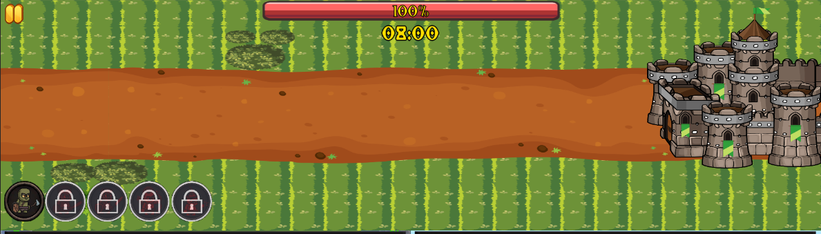

The left side of the pathway is the spawning point of the minions. The right side, as it can be seen, is where the castle is located. All the minions walk in a straight line towards the castle. With every single level, excluding the first one, different amount of strongholds will appear between the spawning point and the castle.

**<Media List>**

**Whack-a-mole**

Only one animation was added to the game and it was to animate the “hiding” and “showing” motions in the mini game called whack-a-mole. To create the animation to different frames were used as shown below:

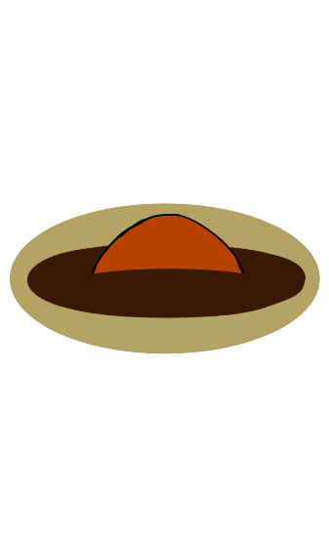 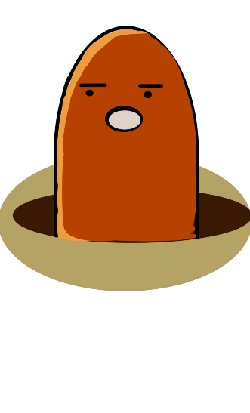 

The background for this mini-game will be also shown below:

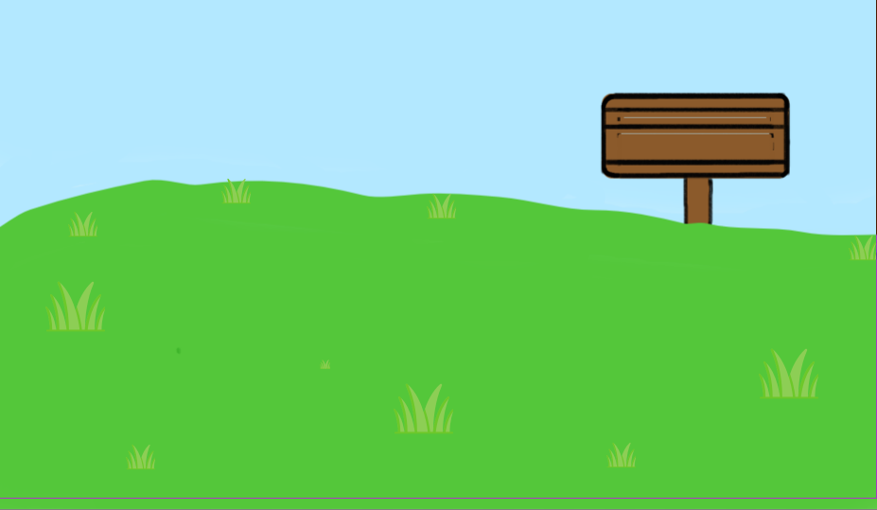

The “grass”-part of the image is used as the area on which the moles will be spawned.

**Gravity balls**

For the gravity balls mini game 4 different ball colors were used for questions that revolve around color matching:

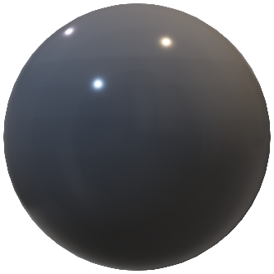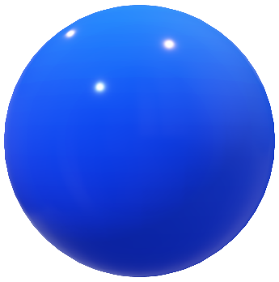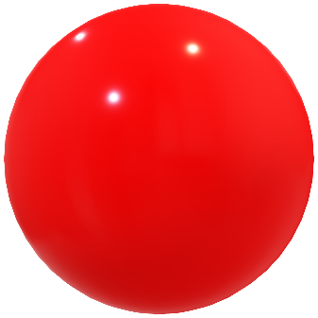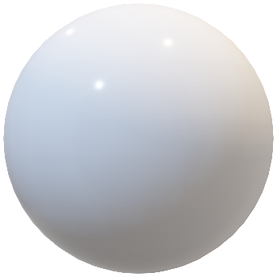

Also the following model was used when the questions that include numbers or letters:

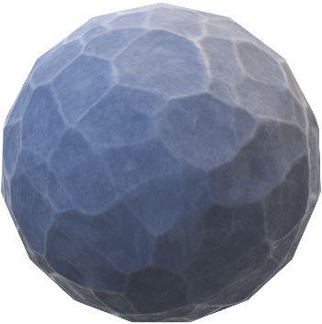

The background chosen for the game is the following:

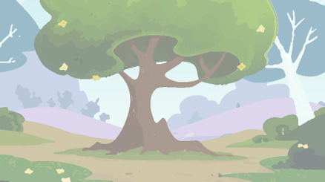

**Main game:**

For the main game many 5 different types of minions were created. Each type has a basic model and 2 upgraded versions of it:

1. Basic minion (green golem):

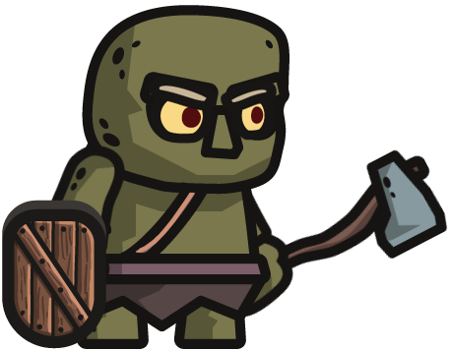 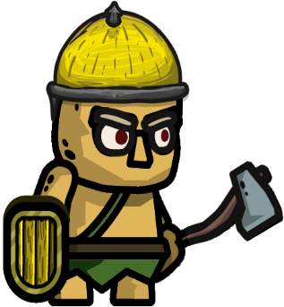 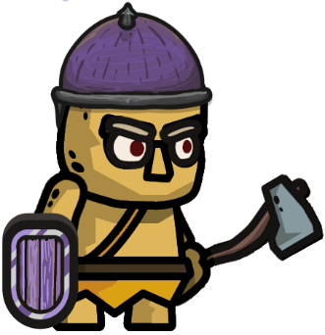

1. Tank minion(undead golem):

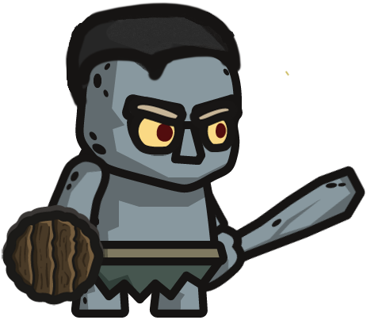 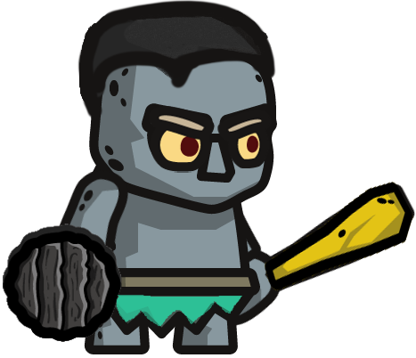 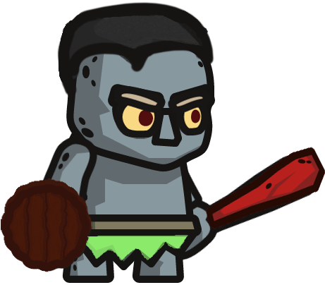

1. Fast minion(wood golem):

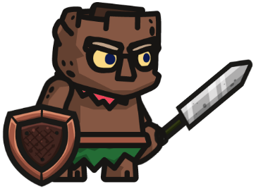 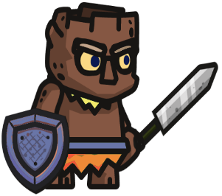 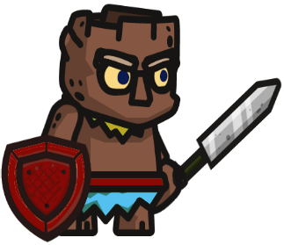

1. Archer minion:

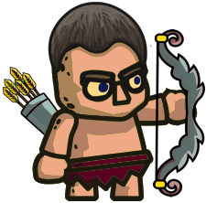 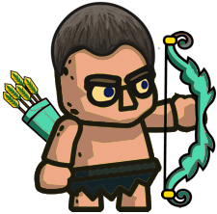 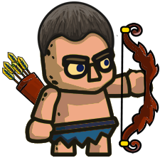

In addition the arrow that is being shot by the archer was also created.

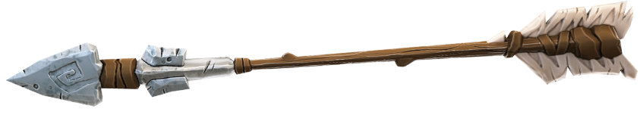

1. Wizard minion:

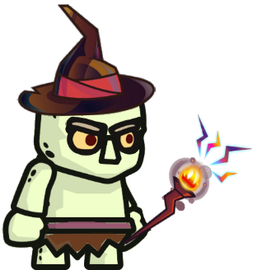 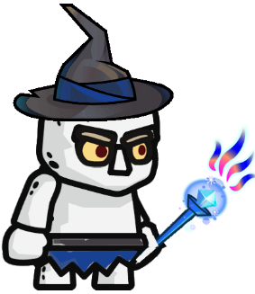 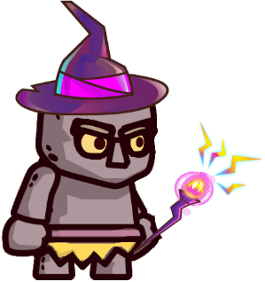

When being upgraded, not only the model of the wizard changes, but also the projectile that’s being shot by them.

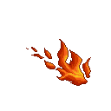 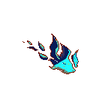 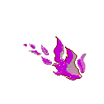





Alongside with the minions and their upgrade frames, additional frames were created to help us animate them. Each minion has a walking, attacking and dying frame. Unfortunately due to lack of time these frames did not end up being used.

The backgrounds used for the main game can be found below. They vary depending on the level.

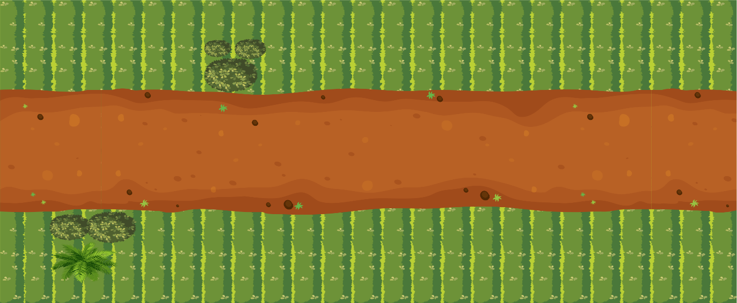

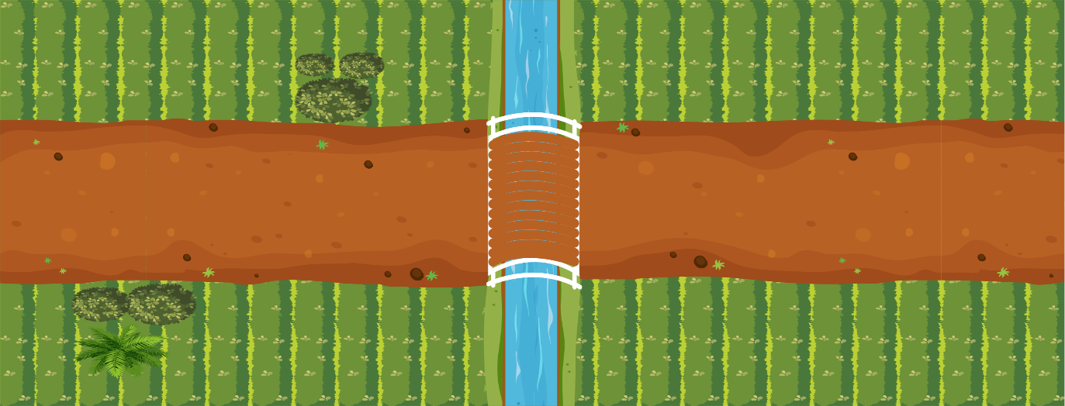

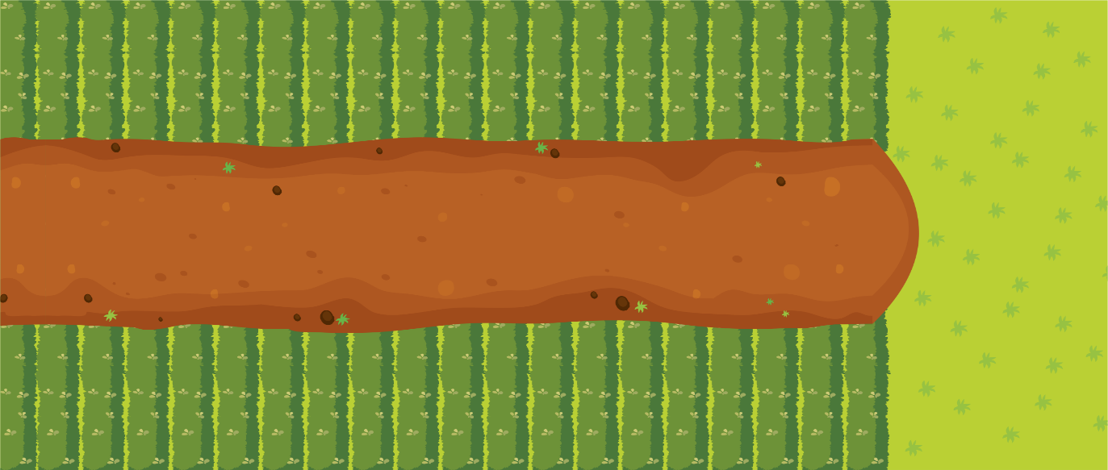

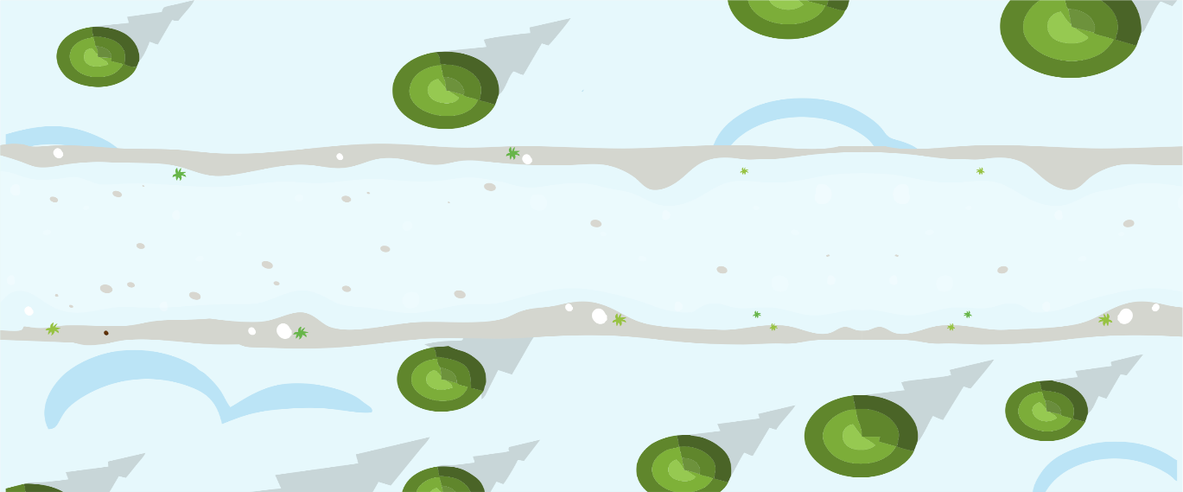

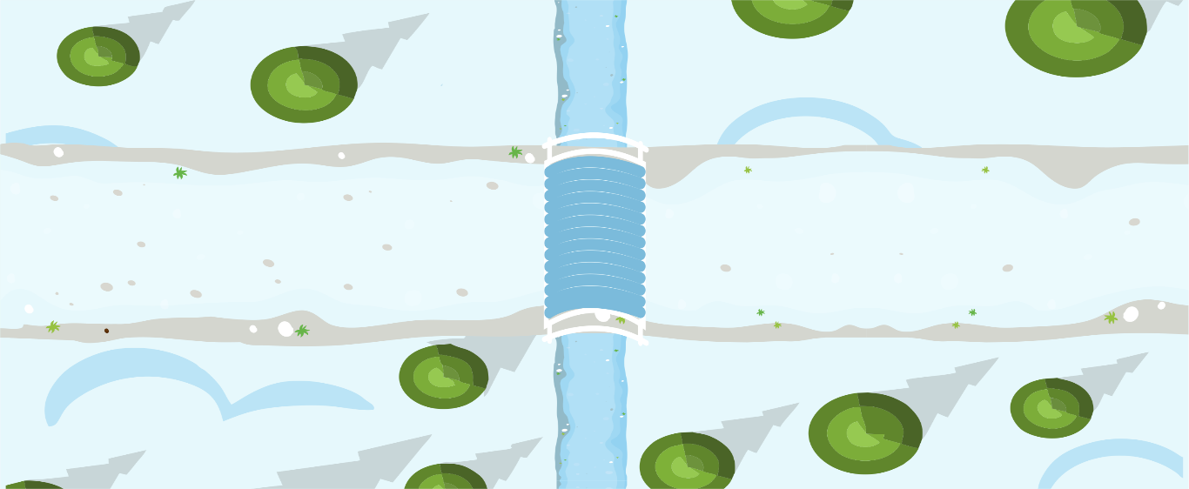

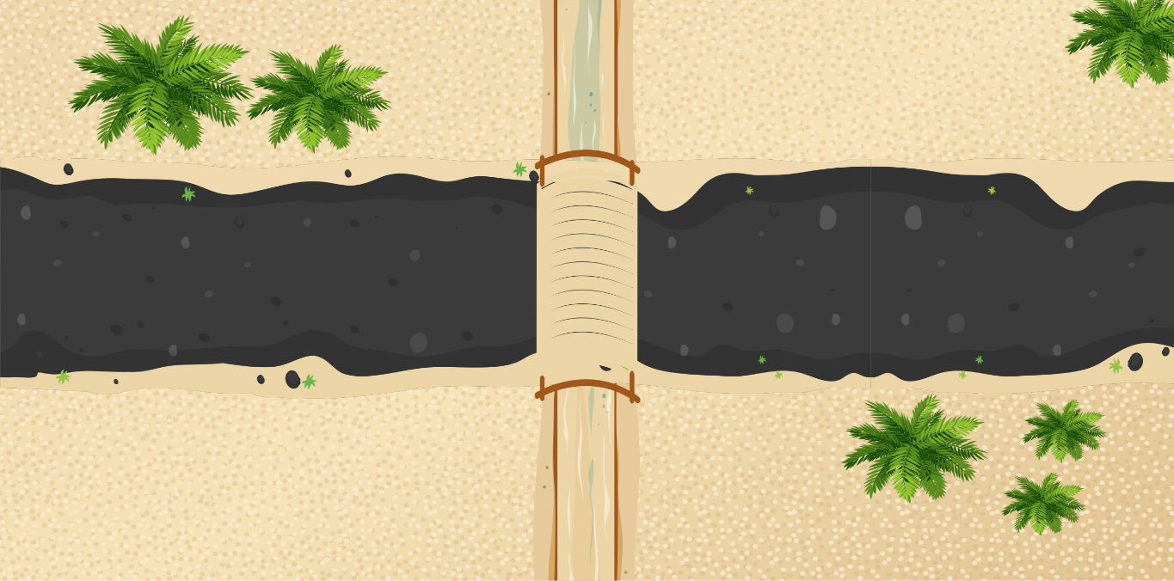

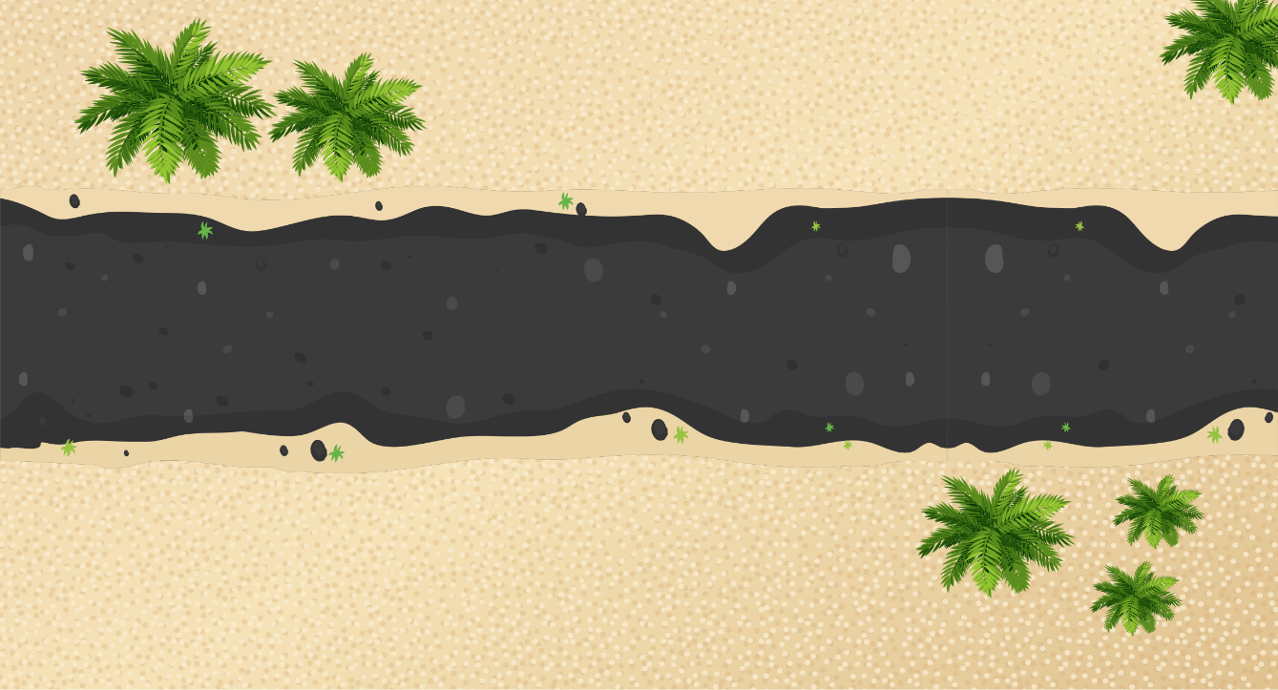

Other assets that were created for our game were the castle, the fortifications (strongholds), the arrows that they shoot, as well as the health bars.

For the health bar the following asset was used:



To add a certain diversity to the game 3 different castle models were created. To be seen by the player, they need to progress through the game. Each model has additional cracked and destroy version of it.

1. First castle model

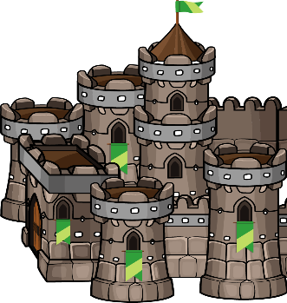 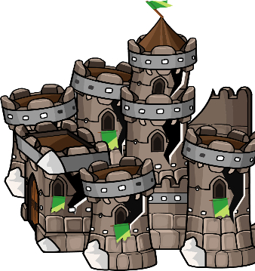 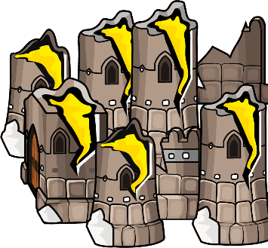

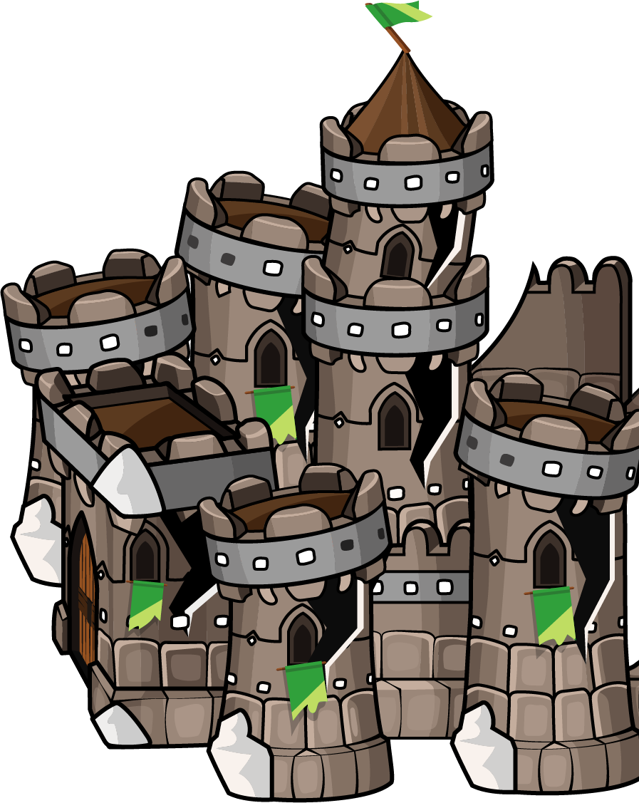

* 

1. Second castle model

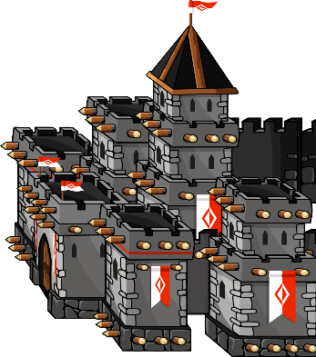 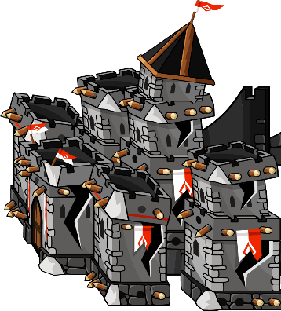 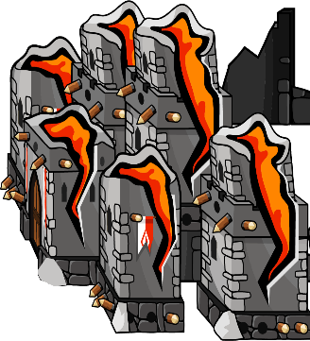

* 
* 

1. Third castle model

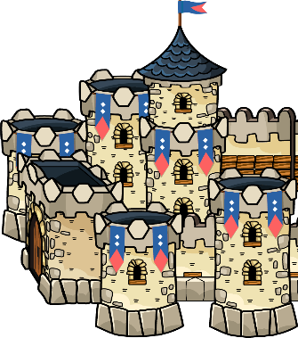 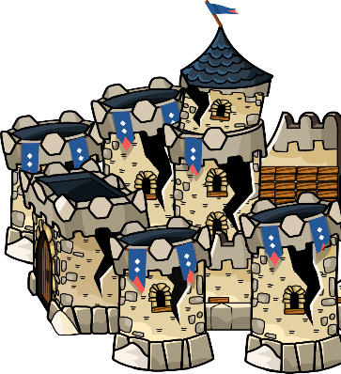 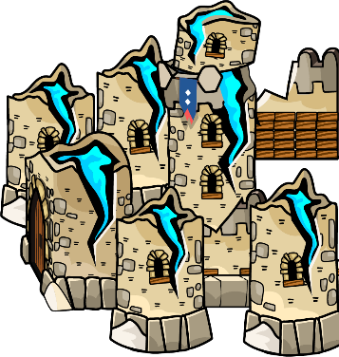

* 
* 

The fortifications (strongholds) were created of 3 separate assets. To create a stronghold 2 tower and a gate were used, having the gate connect both towers. Since there are 3 models for the castle, 3 models for the fortifications were created.

1. First fortification model
   1. Towers

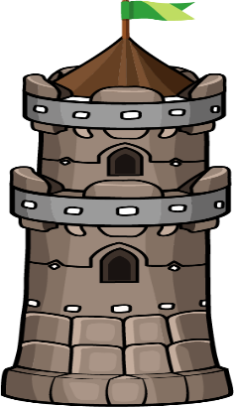 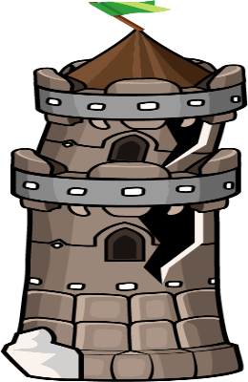 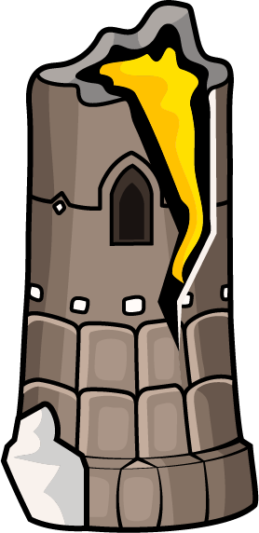

* 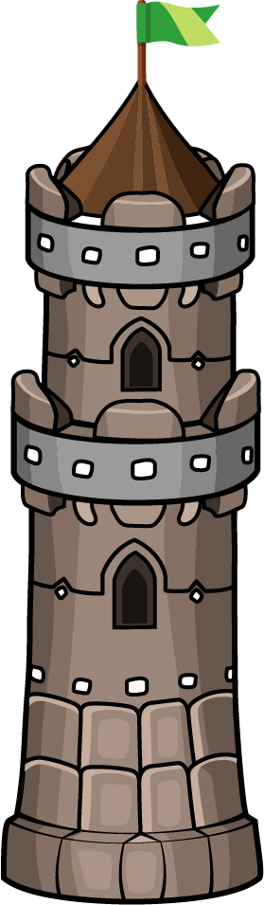
* 
  1. Gate

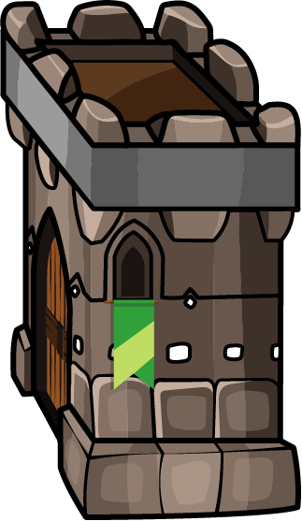 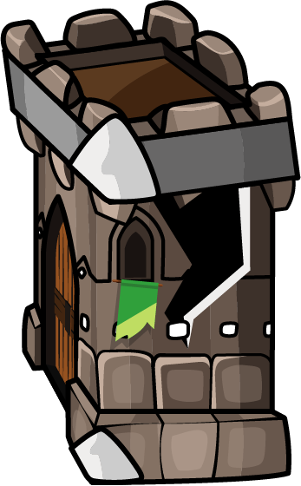 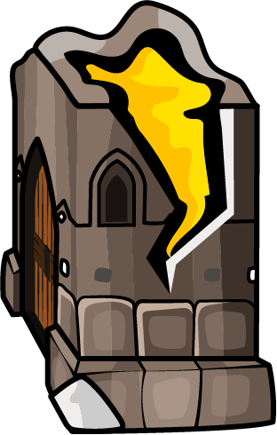

* 
* 

1. Second fortification model
   1. Towers

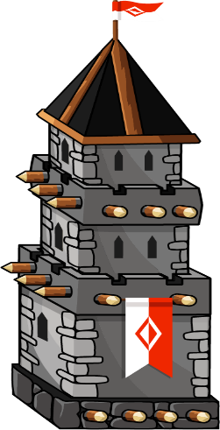 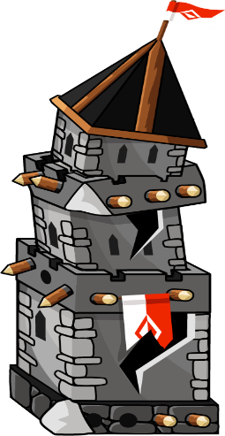 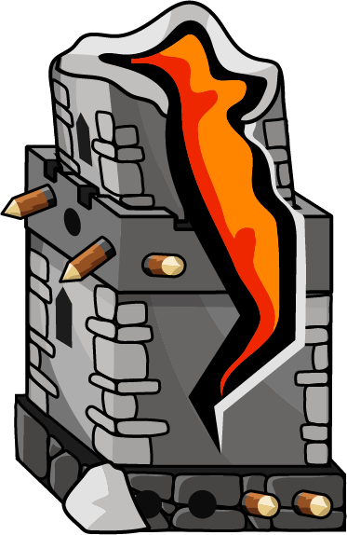

* 
* 
  1. Gate

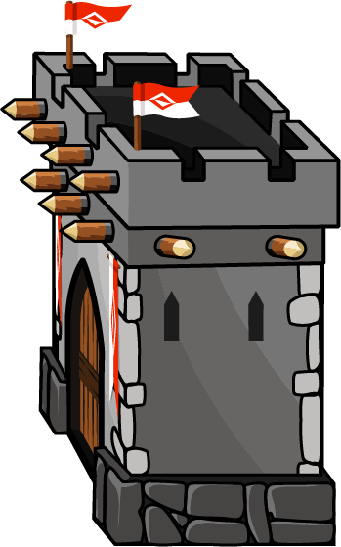 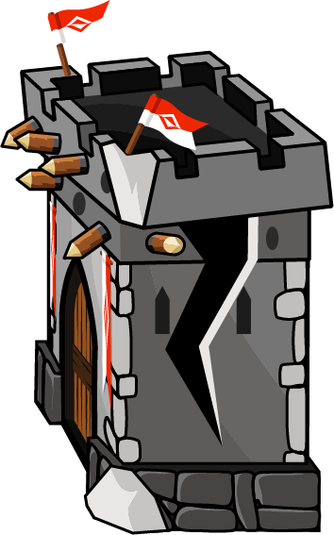 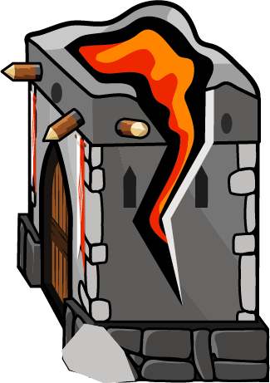

* 
* 

1. Third fortification model
   1. Towers

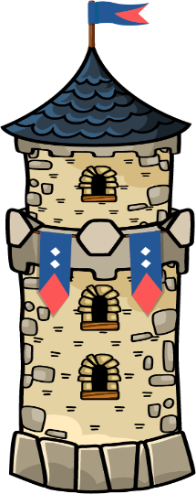 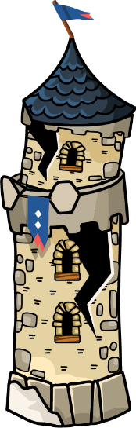 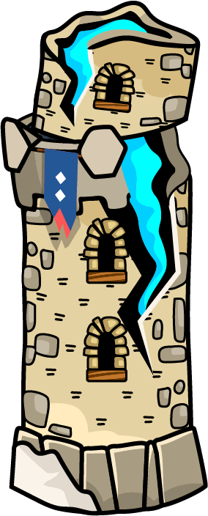

* 
* 
  1. Gate

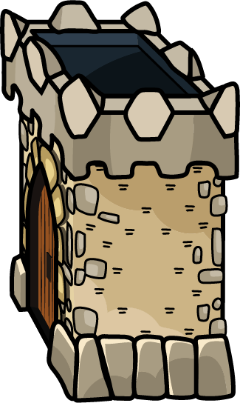 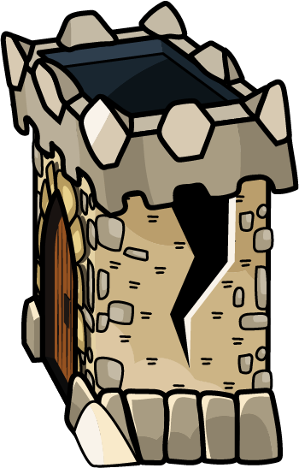 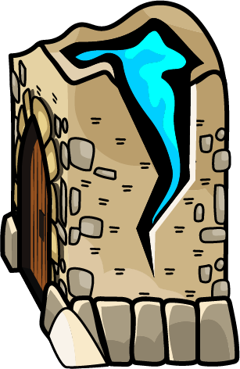

* 
* 

As mentioned earlier an asset for the arrow, which is being shot by the castle and the strongholds, was created as well.

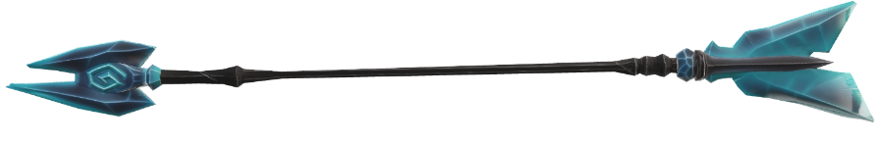

**<Miscellaneous>**

During the development of the game a lot of planning was involved. Some ideas were initially included into our alpha/beta sprint and were later on discarded since they turned out to bring too little value to the project or got discarded simply due to the lack of time.

Idea that got discarded due to lack of value:

1. Changing background depending on the season in the real world. At first that idea sounded nice, but later on proofed to bring almost no if not absolutely no value to the project

Ideas that got discarded due to lack of time:

1. Animations to the minions. Even though the animation frames are already created by the designers, the developer part of the project lacked the time to implement them in the project. Animations suck as minion movement, minion attack and minion dying.
2. Implement background sound and sound effects. Due to the lack of time, this idea got discard as well.
3. Adding more mini-games. Initially the mini-games were supposed to be 4. However, only 2 ended up being implemented in the game.
4. Adding more minions to the game. The game ended up having only 5 types of minions – the basic minion, 2 melee and 2 ranged. However a 6th type is already created. Unfortunately there isn’t a 7th type. Including the fact, that the equality between amount of melee and amount of ranged minions should be kept, we discarded the 6th minion and kept only the first 5 types.

For the future development of the game some of the ideas, if not all of them, that got discarded could be implemented into the game. Also here will be listed some suggestion from the developers:

1. Add more levels to the game
2. Add more types of questions for the mini-games
3. Create a scoring system based on the time needed to win the game.
4. Create dynamic selection of minions, in a way that either the user selects the 4 locked minions before the level or the game selects them at random. Should be however kept in mind that 2 of them should be melee and 2 ranged.
5. Currently the castle focuses 1 minion at a time. It could be implemented that every 10 levels addition arrow is added. The arrows will do 60% of the initial damage, which in the end will be 120% total damage but split amongst the minions.

Further aspects that may help you to comprehensively describe your game

* Game Controls – left mouse click to spawn minions/play mini-games/select upgrades or unlocks and also Esc to open the Pause Menu
* Game Flowchart (Show all the screens from start screen to game over connected with each other)
* Game cameras – 3 cameras are used. They are Orthographic. When the game starts each of them fixates on a different background and changes its size depending on the background image.
* HUD system – there are different types of information indicators on the screen since there are many things happening due to the fact that we have combined 3 games into one. Most of them are self-explanatory. Nonetheless all of them will be noted here.

1. Upon selecting a mini-game the other one is locked:

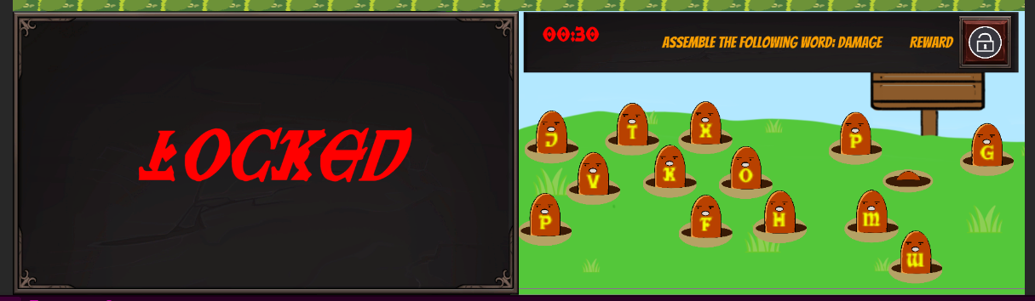

1. If the player gives a wrong answer or runs out of time, the following screen is shown on the respective mini-game

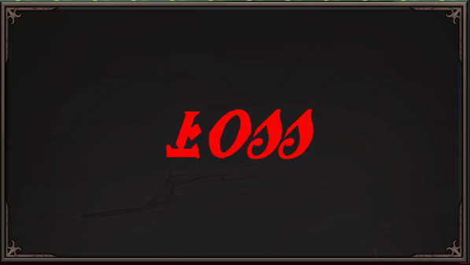

1. If the player gives the correct answer, the following screen is shown

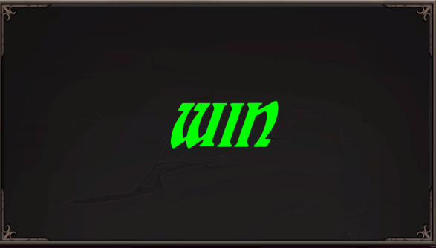

1. 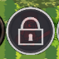Locked minions are indicated by having a lock over their icon
2. 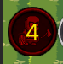Once a minion is being spawned, the respective minion goes on cooldown and once the timer counts down to 0, the user can spawn it again.
3. When an unlock reward is won, the following screen is shown. On it also the basic stats of the respective minion are show. At the top left corner there’s a timer, which shows to the user how many seconds are left to choose a minion to unlock.

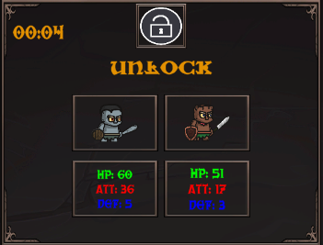

1. 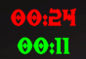There is also a timer for bonus game, which can be seen on some of the side games. Completing the game while the green timer is still shown, gives to the user 50% bonus to the reward.
2. Once the upgrade reward is won the following screen is shown. It also includes by how much the stats of the selected minion will be increased.

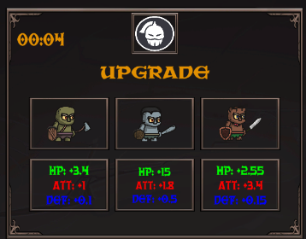

1. The time left and the castle’s health are both indicated at the top of the main game.

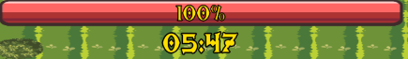

1. In the beginning of level 1, which is also considered the introduction level, an image is show which explain to the user most of the things that they need to know about the game

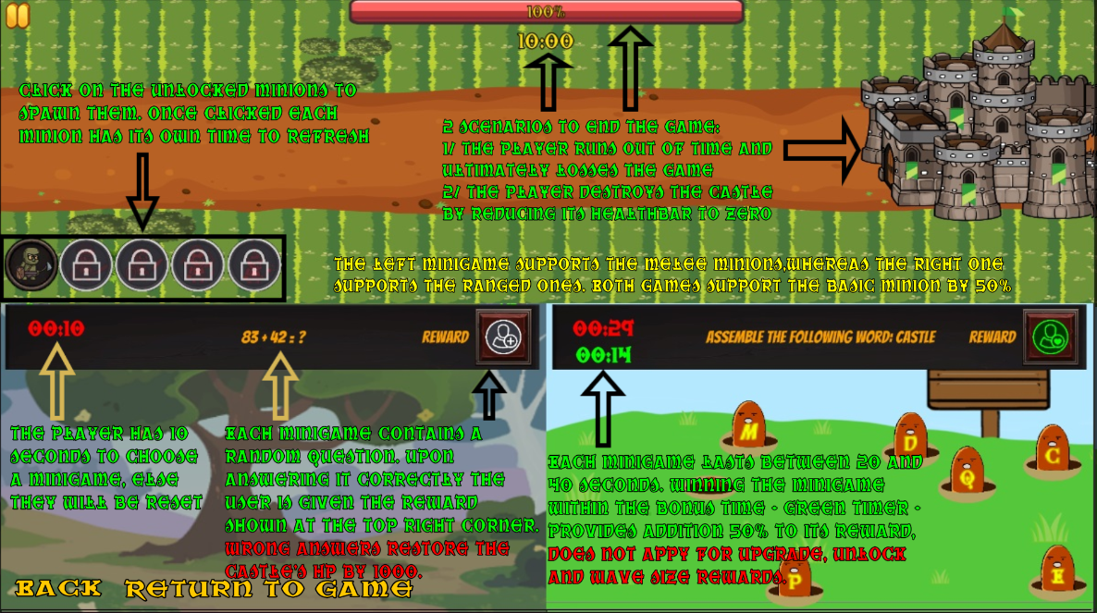

* Player metrics – not all stats are shown. Currently the player can see the health points, attack damage and defense on the minions they unlock, as well as by how much the stats are increased by upgrade. Also the health bars of the castle and the strongholds are shown. The movement speed of the minions is hidden to the player, as well as the attack rate. Nothing beside the castle’s and strongholds’ health bars is shown in order to prevent the users from coming up with strategies to cheese the game.
* Combat – since the no animations could be implemented on the minions, their movement consists of sliding in a straight line from the left to the right until they collide with a stronghold or castle and based on their attack rate and attack damage the health points of the structure start decreasing. Whenever a minion type gets upgraded their outfit gets changed as well. All these changes can be found in the media list, upgrade section.
* Power-ups/state modifiers – these are all the rewards that the user can obtain by winning the mini-games. Below an image with all of them can be seen. This image is also implemented in the game.

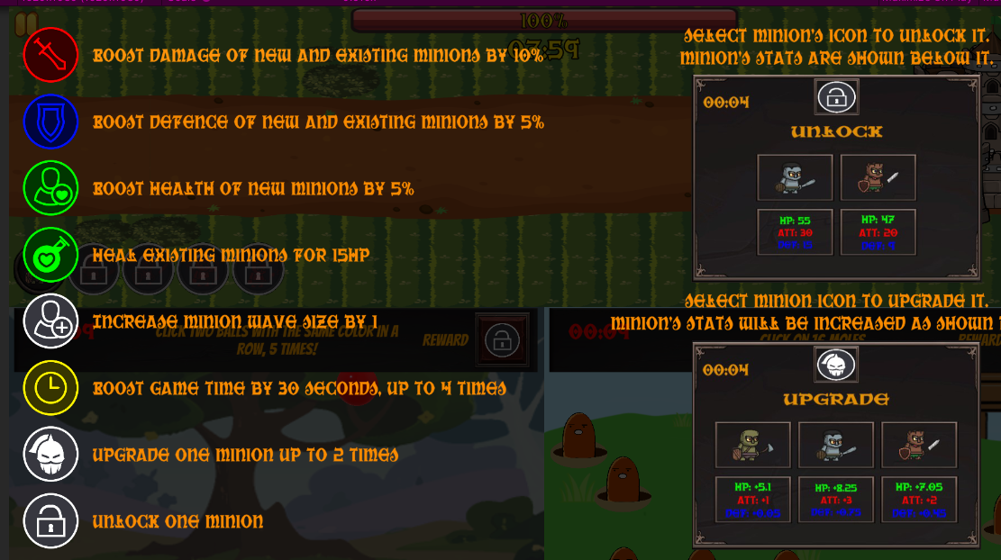

* End game result – once a level is completed, the player is shown the statistics of the level. This included time needed, mini-games played, won and lost.

1. When the player runs out of time:

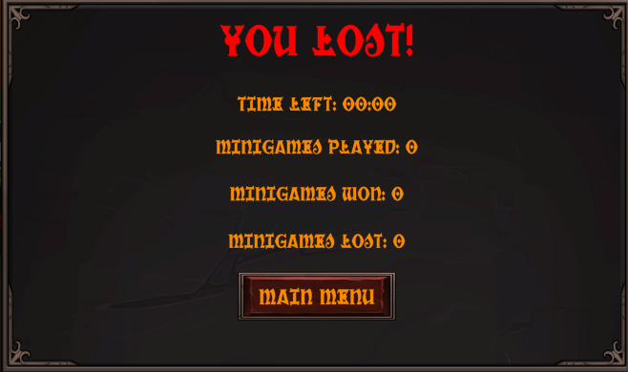

1. When the player completes a level:

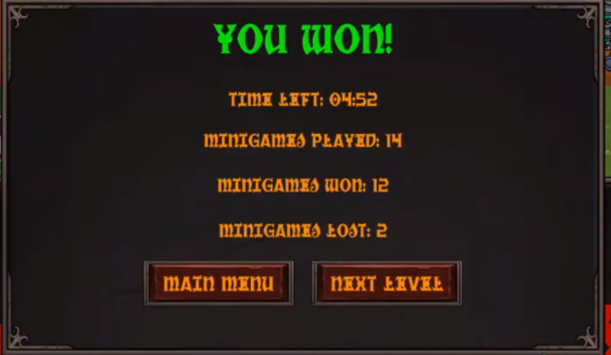

1. When the player completes the final level:

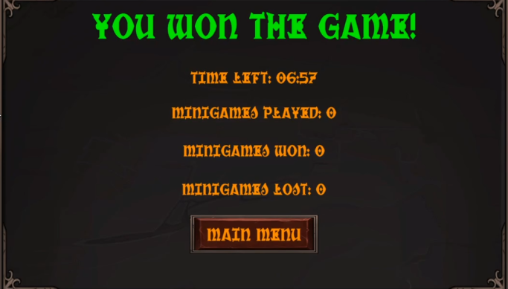

Warning: Should be noted that the above image is just an example of what the screen will look like if the player manages to complete the last level. However by playing 0 mini-games and more importantly by winning 0 of them, the last level cannot be complete.

* Game Progression outline (overview of all game levels/parts of the level, what sections, where are bosses) – the game starts with an introduction level, in which only the enemy castle can be found.

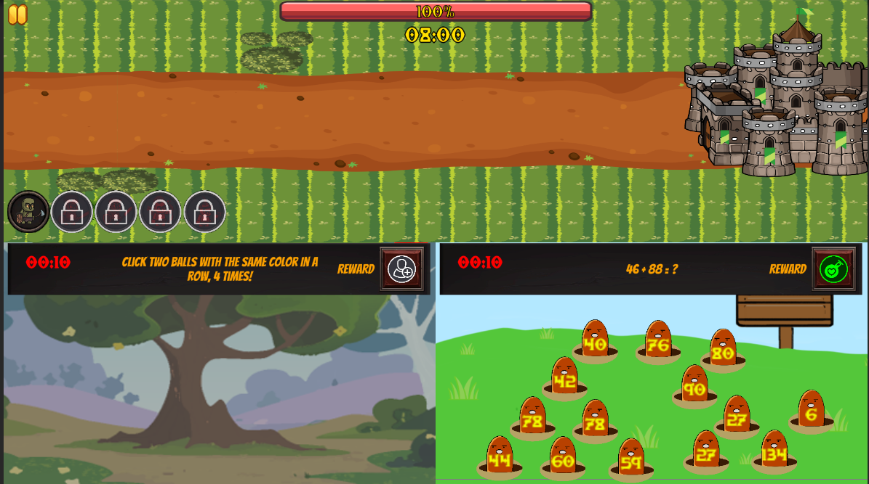

After the completion of level one, the game gets harder and fortifications start to appear on the screen. Level 2 has 1 fortification in front of the castle. Each next level has an additional fortification compared to the previous one. However, every 3 levels, excluding the introduction one, the model of the structures is upgraded, as well as their strength. Thus, the amount of fortifications is again reduced to 1. This means that level 2, 5 and 8 will have 1 fortification, however different structure models. For levels 3,6 and 9 the amount of strongholds will be 2 and for levels 4,7 and 10 – 3 fortifications.

* Enemies – the castle and the stronghold(s). They attack by shooting arrows at the minions. They have health, attack damage, attack range and fire rate. Only the attack range is static throughout all 10 levels – 20 for the castle and 11 for the strongholds. The other stats vary depending on the level. The strongholds are weaker compared to the castle. Initially the castle starts with 5000 health points, 35 attack damage and fire rate of 1.5. These stats go up to 10000 health points, 40 attack damage and 1.75 fire rate. The strongholds on the other hand start at 1000 health points, 20 attack damage and 1 fire rate, going up to 2000 health points, 27 attack damage and 1 fire rate.